4.1 SITEMAP

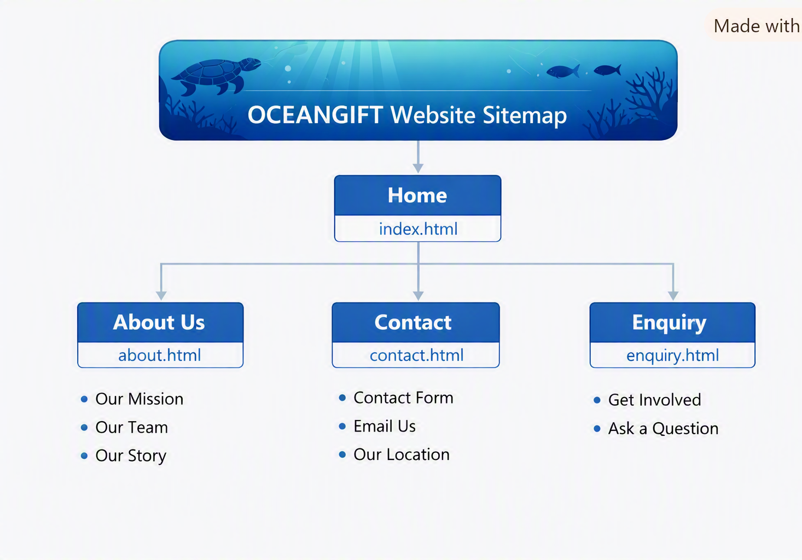
Figure 4.1 – OCEANGIFT Website Sitemap
This sitemap shows the hierarchical structure of the OCEANGIFT website, starting from the Home page and branching into About Us, Contact, and Enquiry pages. Each subpage provides specific information relevant to the organisation’s mission and communication.

(Microsoft Copilot, 2026)

Reference list
1.Microsoft Copilot, 2026. Conversation with AI assistant on sitemap creation. [online] Available at: https://copilot.microsoft.com [Accessed 12 August 2026].

